

**Independent Senior Secondary College for Years 10 to 12**

*4808 Mt Lindesay Highway, North Maclean Q 4280.*

AGTECH Connections

**The newsletter of the Australian Technology & Agricultural College *‘Connecting the College with the Community*’**

**W:** [www.atac.qld.edu.au](http://www.atac.qld.edu.au) **| E:** [admin@atac.qld.edu.au](mailto:admin@atac.qld.edu.au) **| P: +617 5547 8598**

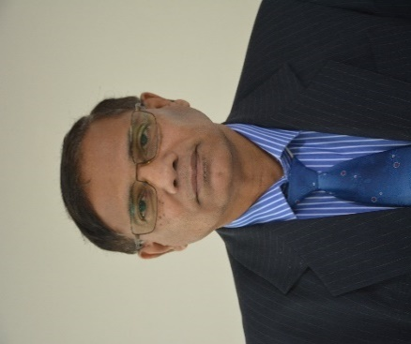

Edition 88: March 2023

/

**College Founder/CEO**

***Dr Narendra Nand***

**Principal’s Message**

In a small and supporting classroom environment the new year 10 students have now adjusted well and completed their Term I. Assessments for Term one have been completed with one-to-one teaching and learning support. Those who follow the instructions are succeeding very well while a few need to become serious and committed to their own academic progress. Re-engagement and re-focus on their careers is being completed by doing work experience and casual jobs. Individualized and realistic pathways are planned along their QCAA requirement. What a great thing to have completed four certificates alongside the completion of Year 12 QCE and starting an early career? Each student receives Certificate II Work for Skills & Vocational Pathways (FSK20119), Certificate II in Workplace Skills (BSB20120) and a Certificate II or III in a trade from TAFE or another RTO. All our year 10 students have registered for Trade Taster program and all year 11 students are enrolled at TAFE for 2023. ATAC is aiding each student into work experience or apprenticeship to meet their expectations, a learning experience that suits their needs and abilities via flexible pathways. ATAC is proud to provide an opportunity and a unique journey with a firm outcome by the end of year 12.

**ATAC TRIPOD MODEL**

ATAC provides an informal and reasonably relaxed and acceptable environment reducing stress and challenges of a formal system. Dreams of “early careers and early incomes” become a reality enabling every child to understand his /her role and responsibility and to become independent learners. The TRIPOD model at ATAC promotes a goodwill, understanding in a small and friendly environment, nurtures learning skills, and builds self-confidence in a less stressful training system. Partnerships with parents/guardians, students and the staff embrace honesty, hard work, responsibility, resilience, and respect as a priority.

The ATAC Board is actively involved in building the infrastructure and capacity building to provide best learning experiences for future onsite training to meet needs of future growth.

**Community Engagement**

The local community, businesses, and parents/ caregivers are regularly contacted by emails, monthly newsletters, social media, ATAC website and at times newspaper articles. We deeply appreciate the response from parents/caregivers supporting our shared responsibility to assist young people in making their dreams come true. ATAC welcomes interested parents, businesses, volunteers, and organizations to join ATAC committee in assisting the Board to support young people in achieving their life goals.

Despite bad weather, members of the North Maclean Community Gardens (NMCG) have been persevering in the heat and rain and are looking forward to growing their vegetables. It provides some supplementary income and great horticultural skills to the community. ATAC encourages community organizations to join NMCG projects to increase horticultural activity in Logan. Our board director, Mr. Daniel Cole is getting ready to start up the nursery production of native species for revegetation and sustainability of our environment.

**Infrastructure Development Plans**

Our multi-purpose shed which had been delayed by almost two years is now under construction. It is expected to be fully ready by the end of April. Earthworks are planned around the sheds to prepare for sewer disposal, nursery, car parks, and road works. The learning spaces, amenities and the commercial kitchen will provide opportunities to increase the numbers to enroll more students for approved courses for senior schooling and higher education. The multipurpose building will also provide an opportunity to host some Council approved public functions onsite.

**Bushfoods Conference 2023**

The first “Australian Bushfoods Conference” incorporating (8th Queensland Bushfoods Conference jointly hosted by ATAC, Queensland Bushfoods Association (QBA) and the Australian Institute of Horticulture (AIH) will be held at ATAC on 27-28th May 2023. The Conference organizing committee chair, Emeritus Professor Rod Drew visited the site this week and is fully confident that the large shed will be able to cater for the two-day national conference. The planning has been in progress since last conference held at ATAC in 2019 which was postponed twice last year due to hardships faced by growers affected by floods and fires. Board Chair, Ms. Irene Bayldon and Dr. Narendra Nand have been discussing the progress at Board meetings and having consultations with local businesses, Logan City Council and QBA. Brochures with more information is available on AIH and ATAC websites.

**Parent/ Guardian Engagement**

We invite parents to work with us in finding work experience and/or apprenticeships for our students as we guide them to achieve their qualifications and QCE points. Young people building personal skills while doing some work or work experience tend to take academic work more seriously as they feel confident that are getting closer to their careers. Opportunities provided by businesses or self-employed tradies helps the parents/guardians and ATAC to facilitate in skills training for our students. Hands-on and practical work has become increasingly important in building positive attitude and skills. With relevant skills and white cards, the employability of our students increases. ATAC works closely with businesses, training organizations and parents/

guardians in empowering students with job-ready skills and knowledge. Our gratitude to all the businesses who have engaged our students and provided them with a bit of income and direction in life.

**The Board of Directors**

What a great relief for the Board of Directors to see the progress of our multipurpose shed. It is all coming to fruition after the multiple setbacks over the past two years. We sincerely appreciate the contribution of our directors for the donations for shed construction, providing sponsorships to needy students, assisting in internal review processes, general cleaning, and maintenance at ATAC and attending the regular monthly meetings. A great volunteer service to the development of our community.

ATAC Board directors are elected at the AGM, inducted at the next board meeting, and provided with mandatory governance training resources. All our members are highly qualified, experienced, and very passionate people who are active community workers, and each member brings in a different knowledge and skills from their own professional backgrounds which is very beneficial to ATAC.

**Gary Suthers**

***English, Humanities, Science and Agricultural Science Teacher***

Thank you for the opportunity to teach your child at ATAC. Term one is finished already, and all students have finished working on their assessments. The year 10 students have finished their song lyrics analysis and have finished researching their case study on how to increase physical activity in our modern world. They have also successfully completed their history, maths, and science examinations.

The senior students in year 11 have found their recipes and have converted it to cater for a dinner party of twelve and they have made a business pamphlet to inform new employers on what their induction will cover over the first few days of a new job. For Agricultural Practices they have completed a safety audit and a safe work procedure for agricultural tools.

Working with our students is a very rewarding experience for me and seeing them all grow in confidence and in skills and knowledge is a great privilege. Over their time here at ATAC, I hope that you will see your young person grow more confident and happier as they gain new skills and learn in other ways.

Thank you to all parents and guardians, for your continued support of your child’s learning here at ATAC.

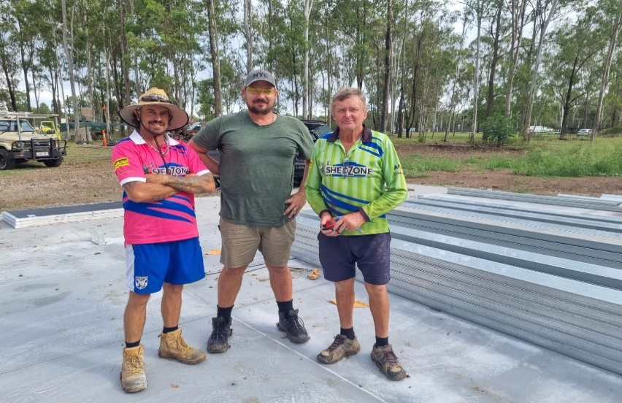

Doug Heathcote, Desmon Senden and Wayne Foureur (L-R) contractors for Shed Zone on the concrete slab ready to start the construction. Doug and his team come from Esk and have camped on site on some nights to complete the shed. Thank you, country folks.

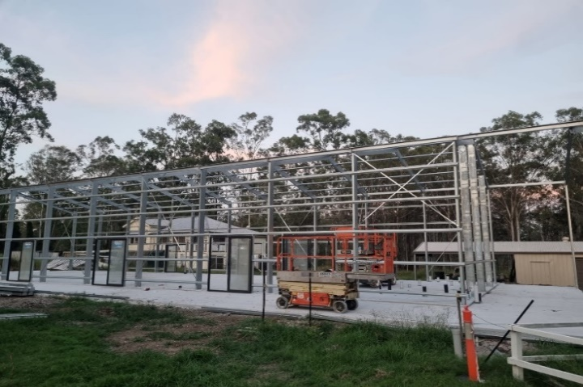

ATAC Shed reaches the structural stage and the walls will come up soon. The roof is scheduled to be completed next week.

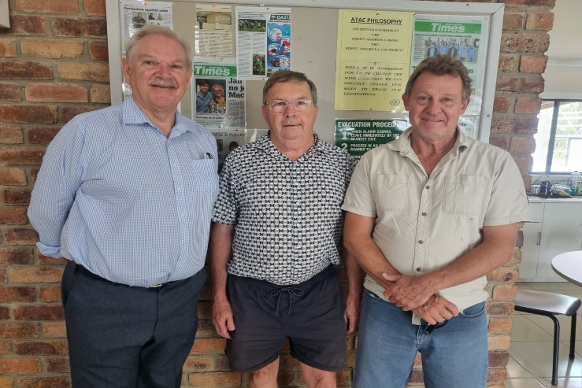

The NSSAB review validator (L) Mr. Nigel Fairburn, ATAC Patron and founding chairman, Emeritus Professor Rod Drew discussed the development of ATAC and the progress it has made since 2016. Carpenter Dave (R) joined Rod to quote for building the amenities and the kitchen in the shed.

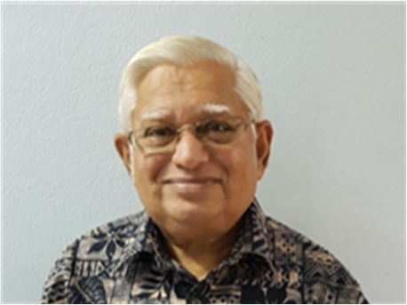

***Mr. Bhagwanji Bhindi***

***Retired Linguistics Lecturer (Sydney*)**

***WOMEN - A TREASURED GIFT***

*A woman is an embodiment of sacrifice, compassion, energy and love*

*A great asset to family, community, society, nation and the world*

*Women and men are like two wheels of a chariot*

*Its smooth movement squarely depends*

*On how the two wheels move in harmony*

*Women and men are not on a rat-race*

*They are expected to work hand-in hand*

*To achieve shared goals in all spheres of activities*

*Therein lies peace and tranquility of humanity*

*Women play multiple roles in family, community, society, nation and the world*

*The complexity of these roles and responsibilities are seldom understood by men*

*This leads to frustrations, depression, negativity and anguish*

*The competitive spirit of women*

*With the sole purpose to surpass men as a sign of victory in the name of equality*

*May not augur well in the long run*

*Women have the intelligence and grit to survive in male dominated fields*

*Proving that women have the determination*

*To excel in numerous domains of human endeavors*

*Let’s join hands to give our full support to women*

*To attain their full potential in all spheres of their lives*

*Women play pivotal role in the progress of humanity*

*They should be encouraged and empowered to access what they aspire for*

*And be given opportunities to use their knowledge, skills, experiences and talents*

*In this changing world driven by digital technology*

*Women have made innumerable contributions to the digital world*

*To make the world a better, peaceful and meaningful place to live in*

*It’s vital to admire, recognize, appreciate, respect and celebrate the feminine energy.*

**Well-Wishers supporting ATAC and our students.**

**They can be contacted via their websites.**



***ENROL for 2023***

**Unique adjustable & supported programs**

**Build Skills for Jobs and/or Apprenticeships.**

**Complete your:**

**QCE (Yr. 12),**

**Cert. II in Skills for Work & Vocational Pathways (FSK20119)**

**Cert. II in Workplace Skills (BSB20120)**

**ATAC RTO #45556**

**Cert. II in a Trade of your choice**

**(TAFE and other RTOs)**

**BSB40520 Cert IV in Leadership and Management**

**BSB50420 Diploma in Leadership and Management**

**BSB50120 Diploma in Business**

**ATAC RTO #45556**

Contact us:

07 5547 8598 or 0432 036 537

E: [enrolment@atac.qld.edu.au](mailto:enrolment@atac.qld.edu.au)

Australian Bushfoods Conference

(8th Qld. Bushfoods Conference)

27-28th May 2023

Hosted by: Australian Technology and Agricultural College

Queensland Bushfoods Association

The Australian Institute of Horticulture

“Design and Development of Urban Landscapes for Bush Food Production”

We invite you to attend the Australian Bushfoods Conference on 27-28th May 2023 to honour the First Australians who had a wide range of uses for these plants including sustenance and medicine; AND ALSO, to support the growers and producers of Bush Foods who suffered devastating damage to their crops and financial security due to the floods in the past 24 months.

Call for speakers and enquiries:

bushfoods@atac.qld.edu.au